library(tidyverse)
## Warning: package 'tidyverse' was built under R version 4.3.3
## ── Attaching core tidyverse packages ──────────────────────── tidyverse 2.0.0 ──
## ✔ dplyr 1.1.2 ✔ readr 2.1.4
## ✔ forcats 1.0.0 ✔ stringr 1.5.0
## ✔ ggplot2 3.5.2 ✔ tibble 3.2.1
## ✔ lubridate 1.9.2 ✔ tidyr 1.3.0
## ✔ purrr 1.0.1
## ── Conflicts ────────────────────────────────────────── tidyverse_conflicts() ──
## ✖ dplyr::filter() masks stats::filter()
## ✖ dplyr::lag() masks stats::lag()
## ℹ Use the conflicted package (<http://conflicted.r-lib.org/>) to force all conflicts to become errors
library(lubridate)
# ----------------------------
# 1) Read + clean names
# ----------------------------
df <- read_csv("focal_group_comparison_main2.csv", show_col_types = FALSE)
names(df) <- names(df) %>%
str_replace_all(" ", "_") %>%
tolower()
# Identify measurement columns
zoo_cols <- names(df)[str_detect(names(df), "^zoo_(count|rel)_")]
reads_cols <- names(df)[str_detect(names(df), "^reads_")] # absolute eDNA reads
edna_rel_cols <- names(df)[str_detect(names(df), "^edna_.*_rel$")] # relative eDNA reads
# Meta = everything else
meta_cols <- setdiff(names(df), c(zoo_cols, reads_cols, edna_rel_cols))
# ----------------------------
# 2) Pivot zoo -> zoo_count / zoo_rel
# ----------------------------
zoo_long <- df %>%
pivot_longer(
cols = all_of(zoo_cols),
names_to = c("metric", "taxa"),
names_pattern = "^zoo_(count|rel)_(.+)$",
values_to = "value"
) %>%
mutate(
taxa = str_to_lower(taxa),
metric = if_else(metric == "count", "zoo_count", "zoo_rel")
) %>%
group_by(across(all_of(meta_cols)), taxa, metric) %>%
summarise(value = sum(value, na.rm = TRUE), .groups = "drop") %>%
pivot_wider(names_from = metric, values_from = value, values_fill = 0)
# ----------------------------
# 3) Pivot absolute eDNA reads: reads_* -> edna
# ----------------------------
edna_abs_long <- df %>%
pivot_longer(
cols = all_of(reads_cols),
names_to = "taxa",
names_pattern = "^reads_(.+)$",
values_to = "edna"
) %>%
mutate(taxa = str_to_lower(taxa)) %>%
group_by(across(all_of(meta_cols)), taxa) %>%
summarise(edna = sum(edna, na.rm = TRUE), .groups = "drop")
# ----------------------------
# 4) Pivot relative eDNA reads: edna_*_rel -> edna_rel
# ----------------------------
edna_rel_long <- df %>%
pivot_longer(
cols = all_of(edna_rel_cols),
names_to = "taxa",
names_pattern = "^edna_(.+)_rel$",
values_to = "edna_rel"
) %>%
mutate(taxa = str_to_lower(taxa)) %>%
group_by(across(all_of(meta_cols)), taxa) %>%
summarise(edna_rel = sum(edna_rel, na.rm = TRUE), .groups = "drop")
# Combine abs + rel eDNA
edna_long <- full_join(edna_abs_long, edna_rel_long, by = c(meta_cols, "taxa"))
# ----------------------------
# 5) Join zoo + eDNA -> final df_long
# ----------------------------
df_long <- full_join(zoo_long, edna_long, by = c(meta_cols, "taxa")) %>%
mutate(
zoo_count = replace_na(zoo_count, 0),
zoo_rel = replace_na(zoo_rel, 0),
edna = replace_na(edna, 0),
edna_rel = replace_na(edna_rel, 0),
taxa = str_replace_all(taxa, "_", " "),
taxa = str_squish(taxa),
taxa = str_to_title(taxa)
)
df_long
## # A tibble: 570 × 17
## sample_code site location station_no date day month year sample_no
## <chr> <chr> <chr> <dbl> <chr> <dbl> <dbl> <dbl> <dbl>
## 1 Pabay_10_12_21_1 Pabay NE 1 10_12… 10 12 2021 6
## 2 Pabay_10_12_21_1 Pabay NE 1 10_12… 10 12 2021 6
## 3 Pabay_10_12_21_1 Pabay NE 1 10_12… 10 12 2021 6
## 4 Pabay_10_12_21_1 Pabay NE 1 10_12… 10 12 2021 6
## 5 Pabay_10_12_21_1 Pabay NE 1 10_12… 10 12 2021 6
## 6 Pabay_10_12_21_1 Pabay NE 1 10_12… 10 12 2021 6
## 7 Pabay_10_12_21_1 Pabay NE 1 10_12… 10 12 2021 6
## 8 Pabay_10_12_21_1 Pabay NE 1 10_12… 10 12 2021 6
## 9 Pabay_10_12_21_1 Pabay NE 1 10_12… 10 12 2021 6
## 10 Pabay_10_12_21_1 Pabay NE 1 10_12… 10 12 2021 6
## # ℹ 560 more rows
## # ℹ 8 more variables: total_zooplankton <dbl>, total_phytoplankton <dbl>,
## # total_reads <dbl>, taxa <chr>, zoo_count <dbl>, zoo_rel <dbl>, edna <dbl>,
## # edna_rel <dbl>
# ============================================================
# 6) Plot: log10(zoo_rel) vs log10(edna_rel)
# - Other in grey
# ============================================================
plot_df <- df_long %>%
filter(zoo_rel > 0, edna_rel > 0) %>%
mutate(
log_rel_zoo = log10(zoo_rel),
log_rel_reads = log10(edna_rel)
) %>%
filter(taxa != "Other")
p <- ggplot(plot_df, aes(x = log_rel_zoo, y = log_rel_reads, colour = taxa)) +
geom_point(alpha = 0.7, size = 2) +
geom_smooth(aes(group = taxa), method = "lm", se = FALSE, linewidth = 1) +
theme_classic(base_size = 14) +
labs(
x = "Log10 relative zooplankton abundance",
y = "Log10 relative eDNA reads",
colour = NULL
)
p
## `geom_smooth()` using formula = 'y ~ x'
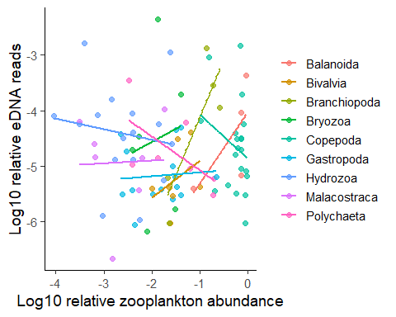
ggplot(plot_df, aes(log_rel_zoo, log_rel_reads)) +
geom_point(alpha = 0.7, size = 2) +
geom_smooth(method = "lm", se = FALSE) +
facet_wrap(~ taxa, scales = "free") +
theme_classic(base_size = 14)
## `geom_smooth()` using formula = 'y ~ x'
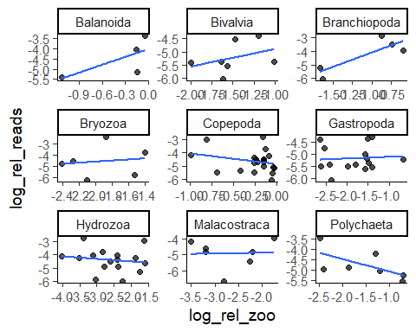
plot_df %>% count(taxa, sort = TRUE)
## # A tibble: 9 × 2
## taxa n
## <chr> <int>
## 1 Copepoda 20
## 2 Hydrozoa 16
## 3 Gastropoda 15
## 4 Bivalvia 7
## 5 Malacostraca 7
## 6 Polychaeta 7
## 7 Bryozoa 6
## 8 Branchiopoda 5
## 9 Balanoida 4
ggplot(plot_df, aes(log_rel_zoo, log_rel_reads, colour = taxa)) +
geom_point(alpha = 0.7, size = 2) +
geom_smooth(aes(group = 1), method = "lm", se = TRUE, colour = "black", linewidth = 1) +
theme_classic(base_size = 14) +
labs(
x = "Log10 relative zooplankton abundance",
y = "Log10 relative eDNA reads",
colour = NULL
)
## `geom_smooth()` using formula = 'y ~ x'
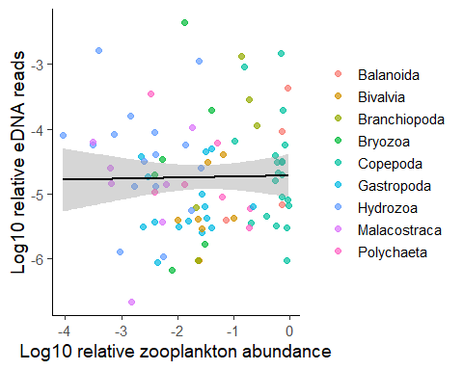
library(dplyr)
library(ggplot2)
taxa_keep <- plot_df %>%
count(taxa) %>%
filter(n >= 10) %>%
pull(taxa)
ggplot(plot_df, aes(log_rel_zoo, log_rel_reads, colour = taxa)) +
geom_point(alpha = 0.7, size = 2) +
geom_smooth(
data = plot_df %>% filter(taxa %in% taxa_keep),
method = "lm", se = TRUE
) +
theme_classic(base_size = 14) +
labs(x = "Log10 relative zooplankton abundance",
y = "Log10 relative eDNA reads",
colour = NULL)
## `geom_smooth()` using formula = 'y ~ x'
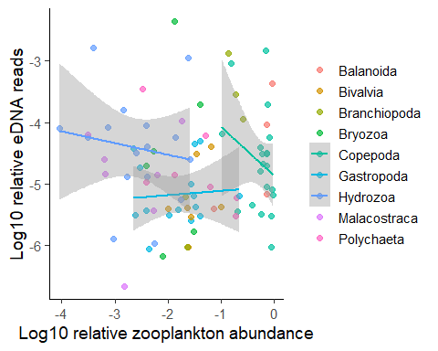
library(dplyr)
library(ggplot2)
lab_df <- plot_df %>%
count(taxa) %>%
mutate(taxa_lab = paste0(taxa, " (n=", n, ")"))
plot_df2 <- plot_df %>%
left_join(lab_df, by = "taxa")
ggplot(plot_df2, aes(log_rel_zoo, log_rel_reads)) +
geom_point(alpha = 0.7, size = 2) +
geom_smooth(method = "lm", se = TRUE, colour = "black") +
facet_wrap(~ taxa_lab, scales = "free") +
theme_classic(base_size = 12) +
labs(x = "Log10 relative zooplankton abundance",
y = "Log10 relative eDNA reads")
## `geom_smooth()` using formula = 'y ~ x'
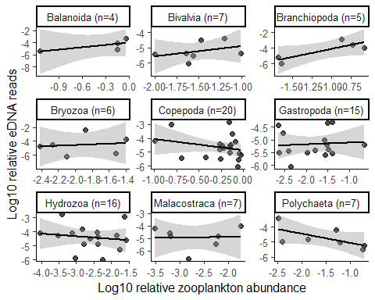
library(dplyr)
corr_tbl <- plot_df %>%
group_by(taxa) %>%
summarise(
n = n(),
spearman_rho = suppressWarnings(cor(zoo_rel, edna_rel, method = "spearman")),
spearman_p = suppressWarnings(cor.test(zoo_rel, edna_rel, method="spearman")$p.value),
.groups = "drop"
) %>%
arrange(desc(n), desc(spearman_rho))
corr_tbl
## # A tibble: 9 × 4
## taxa n spearman_rho spearman_p
## <chr> <int> <dbl> <dbl>
## 1 Copepoda 20 -0.256 0.275
## 2 Hydrozoa 16 -0.294 0.268
## 3 Gastropoda 15 0.146 0.602
## 4 Bivalvia 7 0.607 0.167
## 5 Malacostraca 7 -0.107 0.840
## 6 Polychaeta 7 -0.821 0.0341
## 7 Bryozoa 6 0.257 0.658
## 8 Branchiopoda 5 0.5 0.45
## 9 Balanoida 4 0.8 0.333
corr_tbl %>% filter(n >= 10)
## # A tibble: 3 × 4
## taxa n spearman_rho spearman_p
## <chr> <int> <dbl> <dbl>
## 1 Copepoda 20 -0.256 0.275
## 2 Hydrozoa 16 -0.294 0.268
## 3 Gastropoda 15 0.146 0.602
# ============================================================
# 7) (Optional) Per-taxa correlations on non-zero pairs
# ============================================================
align_tbl <- plot_df %>%
group_by(taxa) %>%
summarise(
n = n(),
spearman_rho = suppressWarnings(cor(log_rel_zoo, log_rel_reads, method = "spearman")),
pearson_r = suppressWarnings(cor(log_rel_zoo, log_rel_reads, method = "pearson")),
.groups = "drop"
) %>%
arrange(desc(spearman_rho))
align_tbl
## # A tibble: 9 × 4
## taxa n spearman_rho pearson_r
## <chr> <int> <dbl> <dbl>
## 1 Balanoida 4 0.8 0.686
## 2 Bivalvia 7 0.607 0.372
## 3 Branchiopoda 5 0.5 0.846
## 4 Bryozoa 6 0.257 0.138
## 5 Gastropoda 15 0.146 0.0788
## 6 Malacostraca 7 -0.107 0.0362
## 7 Copepoda 20 -0.256 -0.262
## 8 Hydrozoa 16 -0.294 -0.155
## 9 Polychaeta 7 -0.821 -0.642
library(dplyr)
library(ggplot2)
# Non-zero pairs (for correlation labels)
df_nz <- df_long %>%
filter(zoo_rel > 0, edna_rel > 0)
# Per-taxa Spearman on non-zero pairs
rho_tbl <- df_nz %>%
group_by(taxa) %>%
summarise(
n = n(),
rho = suppressWarnings(cor(zoo_rel, edna_rel, method = "spearman")),
.groups = "drop"
) %>%
mutate(
label = paste0("ρ = ", round(rho, 2), "\n", "n = ", n)
)
# Data-driven pseudocounts (half smallest non-zero)
pc_zoo <- min(df_long$zoo_rel[df_long$zoo_rel > 0], na.rm = TRUE) / 2
pc_reads <- min(df_long$edna_rel[df_long$edna_rel > 0], na.rm = TRUE) / 2
# Log-transform with pseudocount; flag zeros
plot_df0 <- df_long %>%
mutate(
log_rel_zoo = log10(zoo_rel + pc_zoo),
log_rel_reads = log10(edna_rel + pc_reads),
zero_pair = (zoo_rel == 0 | edna_rel == 0)
)
ggplot(plot_df0, aes(x = log_rel_zoo, y = log_rel_reads)) +
geom_point(aes(alpha = !zero_pair), size = 2) +
scale_alpha_manual(values = c(`TRUE` = 0.25, `FALSE` = 0.85), guide = "none") +
geom_smooth(
data = plot_df0 %>% filter(!zero_pair),
aes(group = 1),
method = "lm", se = FALSE
) +
facet_wrap(~ taxa, scales = "free") +
geom_text(
data = rho_tbl,
aes(x = -Inf, y = Inf, label = label),
inherit.aes = FALSE,
hjust = -0.05, vjust = 1.1,
size = 3.5
) +
theme_classic(base_size = 14) +
labs(
x = "Log10 relative zooplankton abundance",
y = "Log10 relative reads"
)
## `geom_smooth()` using formula = 'y ~ x'
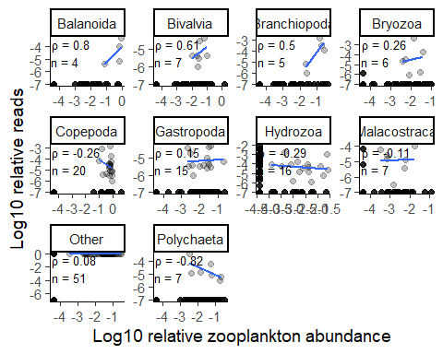
plot_df_2 <- df_long %>%
mutate(
date = dmy(str_replace_all(date, "_", "/")), # handles 15_6_2021 or 15/6/2021
day = day(date),
month = month(date),
month_name = month(date, label = TRUE, abbr = F),
year = year(date),
month_year_date = floor_date(date, "month"),
month_year = format(month_year_date, "%b-%Y")
) %>%
arrange(month_year) %>%
filter(month_year != "Jun-2021")
library(dplyr)
library(ggplot2)
library(forcats)
library(scales)
##
## Attaching package: 'scales'
## The following object is masked from 'package:purrr':
##
## discard
## The following object is masked from 'package:readr':
##
## col_factor
# ensure Other is last
plot_df_2 <- plot_df_2 %>%
mutate(taxa = fct_relevel(taxa, "Other", after = Inf))
# build a manual fill palette: grey for Other, default ggplot hues for the rest
taxa_levels <- levels(plot_df_2$taxa)
other_col <- "grey70"
pal_rest <- scales::hue_pal()(sum(taxa_levels != "Other"))
pal <- setNames(rep(NA_character_, length(taxa_levels)), taxa_levels)
pal[taxa_levels != "Other"] <- pal_rest
pal["Other"] <- other_col
ggplot(plot_df_2, aes(x = month_year_date, y = zoo_rel, fill = taxa)) +
geom_col(position = "fill") +
scale_y_continuous(labels = percent) +
scale_x_date(date_labels = "%b-%Y", date_breaks = "1 month") +
scale_fill_manual(values = pal) +
labs(x = NULL, y = "Relative Zooplankton abundance (cells/L)", fill = NULL) +
theme_classic() +
theme(axis.text.x = element_text(angle = 45, hjust = 1, vjust = 1))
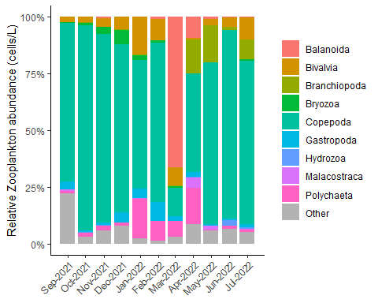
library(dplyr)
library(ggplot2)
library(forcats)
library(scales)
# ensure Other is last
plot_df_2_edna <- plot_df_2 %>%
mutate(taxa = fct_relevel(taxa, "Other", after = Inf))
# manual fill palette: Other grey, others default ggplot hues
taxa_levels <- levels(plot_df_2_edna$taxa)
pal_rest <- scales::hue_pal()(sum(taxa_levels != "Other"))
pal <- setNames(rep(NA_character_, length(taxa_levels)), taxa_levels)
pal[taxa_levels != "Other"] <- pal_rest
pal["Other"] <- "grey70"
ggplot(plot_df_2_edna, aes(x = month_year_date, y = edna_rel, fill = taxa)) +
geom_col(position = "fill") +
scale_y_continuous(labels = percent) +
scale_x_date(date_labels = "%b-%Y", date_breaks = "1 month") +
scale_fill_manual(values = pal) +
labs(x = NULL, y = "Relative eDNA reads (ASV)", fill = NULL) +
theme_classic() +
theme(axis.text.x = element_text(angle = 45, hjust = 1, vjust = 1))
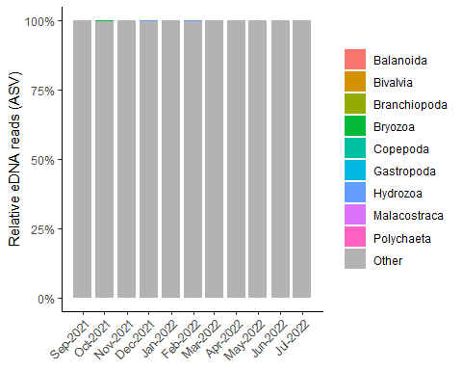
library(dplyr)
library(ggplot2)
library(forcats)
library(scales)
# ensure Other is last
plot_df_2_edna <- plot_df_2 %>%
mutate(taxa = fct_relevel(taxa, "Other", after = Inf)) %>%
filter(taxa != "Other")
# manual fill palette: Other grey, others default ggplot hues
taxa_levels <- levels(plot_df_2_edna$taxa)
pal_rest <- scales::hue_pal()(sum(taxa_levels != "Other"))
pal <- setNames(rep(NA_character_, length(taxa_levels)), taxa_levels)
pal[taxa_levels != "Other"] <- pal_rest
pal["Other"] <- "grey70"
ggplot(plot_df_2_edna, aes(x = month_year_date, y = edna_rel, fill = taxa)) +
geom_col(position = "fill") +
scale_y_continuous(labels = percent) +
scale_x_date(date_labels = "%b-%Y", date_breaks = "1 month") +
scale_fill_manual(values = pal) +
labs(x = NULL, y = "Relative eDNA reads (ASV)", fill = NULL) +
theme_classic() +
theme(axis.text.x = element_text(angle = 45, hjust = 1, vjust = 1))
